Chapter 1
1 |  |  | 15
2 |  |  | 16
3 |  |  | 17
4 |  |  | 18
5 |  |  | 19
6 |  |  | 20
7 |  |  | 21
8 |  |  | 22
9 |  |  | 23
10 |  |  | 24
11 |  |  | 25
12 |  |  | 26
13 |  |  | 27
14

바나나 잉글리쉬

Chapter 2
1 |  |  | 10
2 |  |  | 11
3 |  |  | 12
4 |  |  | 13
5 |  |  | 14
6 |  |  | 15
7 |  |  | 16
8 |  |  | 17
9
Chapter 3
1 |  |  | 6
2 |  |  | 7
3 |  |  | 8
4 |  |  | 9
5 |  |  | 10

Chapter 4
1 |  |  | 9
2 |  |  | 10
3 |  |  | 11
4 |  |  | 12
5 |  |  | 13
6 |  |  | 14
7 |  |  | 15
8

Chapter 5
1 |  |  | 11
2 |  |  | 12
3 |  |  | 13
4 |  |  | 14
5 |  |  | 15
6 |  |  | 16
7 |  |  | 17
8 |  |  | 18
9 |  |  | 19
10
Chapter 6
1 |  |  | 10
2 |  |  | 11
3 |  |  | 12
4 |  |  | 13
5 |  |  | 14
6 |  |  | 15
7 |  |  | 16
8 |  |  | 17
9 |  |  | 18

Chapter 7
1 |  |  | 17
2 |  |  | 18
3 |  |  | 19
4 |  |  | 20
5 |  |  | 21
6 |  |  | 22
7 |  |  | 23
8 |  |  | 24
9 |  |  | 25
10 |  |  | 26
11 |  |  | 27
12 |  |  | 28
13 |  |  | 29
14 |  |  | 30
15 |  |  | 31
16 |  |  | 32
Chapter 8
1 |  |  | 6
2 |  |  | 7
3 |  |  | 8
4 |  |  | 9
5

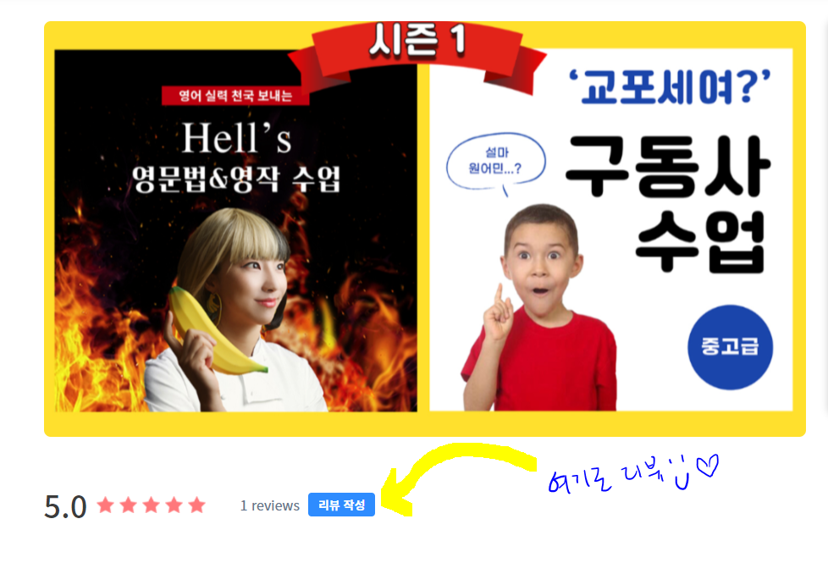
수업 완강을 축하드립니다
리뷰를 정성껏 남겨주시는 학생분에게 근사한 선물이 있어용!
https://liveklass.com/ch/bananaenglish
리뷰 남기러 가기

