바나나 잉글리쉬

Chapter 1
Although he wanted to (1)stay in, Josh’s friends wanted him to (2)go out. It had been a long time since he had gone out with them. In fact, it had been a long time since he had (3)stepped out of his house at all. He would (4)lock himself in every day and (5)sleep through most of the hours. His friends often wondered why he did this. They wanted him to (6)hang with them, but he never did. The truth was that he was lonely. He was not lonely because of (7)a lack of friends. It was actually because he had no girlfriend.
If he had a girlfriend, he could (8)hang out with her and be happy. All of his problems would (9)melt away. However, the more he (10)settled in his house and did not (11)go out, the less likely he was to find a girlfriend. The more his chances of finding love seemed to (12)fade away, the more unhappy he became. The sense of humor that once made Josh the great person he was seemed to be (13)going away. So much so that he would even (14)push his friends (15)away.
Josh’s friend, Lucas, was (16)running out of patience with his friend. He did not want them to (17)fall out, but their friendship would (18)slip away if this (19)carried on. One Friday, Josh’s phone rang. It was Lucas.
“Hi Lucas,” said Josh. Before he could say anything else, Lucas interrupted him.
“Josh, don’t try and interrupt me because I’ll just (20)talk over you. I haven’t (21)heard from you in ages, but tonight, we are (22)going out. I’m going to (23)swing by and (24)pick you up in an hour. You can’t (25)get away from this one. It’s happening. I’ve got someone I want you to meet. With any luck, you’ll (26)get off with her. If not, you can just have a laugh with us. No arguments, I’ll see you in an hour.” Without saying anything else, Lucas (27)hung up the phone.

Chapter 2
Immediately, Josh became anxious. This was his first night out in months. He had barely spoken to his friends, let alone with complete strangers. Lucas was clearly saying that this was a date. It was not just a date. It was the worst kind of date, a blind date! Still, he hadn’t been given much choice. He would have to (1)blunder through this evening one way or another. There was no way he could (2)run away now. Even if he tried to stow away somewhere in the house and (3)lock Lucas out, Lucas would still (4)get him out somehow.
Although Josh wanted a girlfriend, he didn’t want to meet a new girl. Of course, this was a bit of a problem. How could he meet someone new if he never met anyone new? It was impossible. Despite wanting a girlfriend, Josh (5)shied away from girls, worried that he would (6)frighten them away.
There was just one hour to get ready and make himself presentable. He could not (7)walk out the door for a date with his long beard and dirty clothes. So, he had to (8)jump in the shower (9)straight away and start to give himself a quick makeover.
Luckily, Lucas was a bit late. He (10)arrived in his car and (11)knocked on the front door. Josh (12)let him in. He was relieved that Lucas was not early because he might have (13)walked in on him while he was still washing.
“Are you nervous?” asked Lucas as they met at the door.
“Of course,” replied Josh as he tentatively (14)walked through the door.
“Don’t worry. I’ll be (15)with you the whole time!”
They (16)got in the car and (17)went off to the date, with Josh’s worries still running high.

Chapter 3
The date was at a restaurant. Lucas’s girlfriend Sue was coming as well, so it would be a double date. It had been a long time since Josh had (1)eaten out. He thought to himself that it would be cool to eat some nice food for a change, rather than just having microwave meals. He (2)coped well with awful food at home, but it would still be a pleasant change to have something different.
They got to the restaurant, and the date was already there. Josh had been told about her on the way there. Her name was Laura, and she worked with Sue. Sue had noticed that Josh had been reclusive and refused to (3)come out all of the time. She (4)figured out the reason, and it was she who had (5)set up the date.
As soon as they walked in, Josh saw Laura. She was beautiful! He liked the look of her so much that he almost (6)blurted out some things that he knew he would regret when they first met. Luckily for him, he managed to control himself.
“Pleased to meet you,” he said, quite casually as he shook her hand.
She (7)stretched out a hand to shake his. She flashed him a big beaming smile and replied, “You too, I’ve heard so much about you. Let’s have a fun night.” Just seeing that smile made blood rush to Josh’s face. He knew that he liked her already. He just hoped that his nervousness wouldn’t (8)boil over.
Even though she looked confident, Laura was nervous too. She hated the idea of (9)asking out a boy, and Sue had forced her to (10)come along, just in the same way that Lucas had forced Josh. In any case, the date was happening now.

Chapter 4
Immediately, the conversation started to flow between the four people. They (1)laughed away the night. The chats (2)went on for hours. There were chats about small things, important things, trivial things, funny things, serious things. They (3)spoke about all things. Before too long, it was no longer a conversation between four. More and more, Laura and Josh spoke to each other directly, ignoring the other two.
Josh secretly wished that they could (4)slip away to another table where their friends could not hear them. Instead of having to (5)push through the evening, they had (6)sailed through it. Even though the night was not over, Josh still wondered in his head when he would next see Laura. Laura thought something similar. She wondered how many days at work she would have to (7)slave away before she would next see Josh.
The other two, Sue and Lucas, realized that their date was a success and decided to (8)back away. They made their excuses and left, leaving Laura and Josh to (9)get on with each other. The new couple stayed at the restaurant for hours even after that. In fact, it was only when the staff started to (10)clear away the tables that they realized it was time to go home.
“They are going to (11)boot us out soon. Can I (12)go with you?” asked Josh, “You know, to walk you home.”
“Sure, you can (13)come with me,” replied Laura.
They finished with their drinks and (14)walked away from the restaurant. As they (15)headed out into the cold, Josh offered Laura his jacket. She smiled – he was her kind of guy.

Chapter 5
Laura did not live very far away from the restaurant. She had (1)walked over to the restaurant earlier that night, and it was easy to (2)walk about. Josh was disappointed because he wanted to spend even more time with her. The short walk was not enough time. They reached her door in just a matter of minutes.
“I’m not going to (3)ask you in,” she said at the door.
“I wasn’t expecting you to. It was great meeting you, but I’m not (4)getting carried away.”
She (5)stepped away slightly, “Okay then. It was lovely meeting you, and I’d love to do it again. As long as you are happy to….”
Josh chuckled, “Yeah, of course. I’m happy to! I’m going to (6)level with you – this was the most fun I’ve had in a long time,”
“Me too!” said Laura, “I’ll let you in on a secret. I haven’t (7)been out on a date in months, and it’s been (8)getting me down.”
“I think we are in the same boat!” replied Josh. He was relieved that she was having the same problems as him and that he could (9)let out the truth. “I’ll (10)take you out next week?”
“Sure! Goodnight.”
“Goodnight.”
There was an awkward silence as neither of them (11)turned away. Josh (12)breathed in and (13)went for it. He leaned towards Laura and kissed her. He expected her to be surprised, but she didn’t seem it. She (14)reached out a hand and (15)put it around his back. The kiss lasted a few seconds, a few seconds, which proved to be the best that either of them had had in years. Without another word, Josh turned and (16)walked away into the night.
The night had (17)turned out perfectly. He was so glad that he had not let the opportunity (18)pass by and that he didn’t tell Lucas to (19)stay away.

Chapter 6
The next morning, Josh (1)woke up with a start. He had overslept. It was such an emotionally grueling night the night before that he had (2)slept through his alarm. (3)Looking through the window, he could see that it was an overcast day. The clouds in the sky made the day dark, but even so, the whole world seemed brighter to Josh.
He (4)jumped out of bed and got ready for work. That whole day was so easy. Just spend the whole time (5)plodding away through his work thinking of Laura and what a great night they’d had the night before. After work, he (6)bumped into Lucas on his way home and thanked him for (7)setting them up.
“I’m glad to hear it,” said Lucas. “In fact, Sue and I are (8)heading out to go bowling tonight. Do you and Laura want to come? I can ask Sue to invite her.”
Josh nodded, “Sure thing, see if she can (9)drop by.”
Lucas called Sue on his phone and spoke to her for a couple of minutes. He looked solemn as he (10)put the phone down.
“Okay, so a slight problem. Laura says she doesn’t want to come. She liked you a lot, but she’s just not ready to be seeing anyone right now.”
It was hard for Josh to stop his emotions from (11)spilling over. He was distraught. How could she have (12)tossed him away so quickly? It wasn’t fair! At least she had (13)got it over with quickly, rather than (14)dragging it out. She had not (15)quarreled with him or (16)screwed with him in any way. That was good.
“Cheers for letting me know,” said Josh, trying to be calm, “I’ll give bowling a miss and probably just go home tonight.”
Lucas nodded understandingly. “I’ll (17)drop by in a few days to make sure you’re okay.” Josh (18)walked off, trying not to cry.

Chapter 7
On his way home, Josh had an idea. There was no point in (1)going down without a fight. He would (2)go over to Laura’s house and have one last attempt to (3)win her back. If she rejected him, then there was no point in (4)crying over spilled milk, but he at least had to try. Before even going home from work, he (5)ran over to Laura’s house and (6)knocked on the door.
She (7)fiddled with the latch and opened the door to see him on the other side. “What are you doing here?” she asked.
“I know you said you don’t want to (8)go out with me, but I (9)disagree with you,” he said surprisingly confidently.
“You don’t have to (10)agree with my decision, but it’s what I’ve decided. You can’t change my mind. You have to (11)deal with it.” She was quite firm with her response.
Josh did not (12)back down, “No, you are just scared that things won’t (13)work out, so you are (14)pushing me away. You can (15)come to terms with being scared. I’m scared too. We (16)can talk through these things and (17)work through any problems. Let’s just give this a chance! We had a great night last night. Don’t (18)throw it away just because you’re a little bit worried. I don’t want to have to keep (19)starting over with different people. I’m (20)running out of chances to find someone like you. So please, can I (21)come in so we can talk about this?”
There was silence while Laura (22)thought through what he had just said. If it wasn’t her house, she would have (23)run away. Subconsciously, she did (24)back away a few steps. Even though it made sense to her to (25)turn away and (26)go back inside, she made a conscious decision to (27)step out onto the porch.
“Okay, we can give things a go,” she said, “We’ll (28)plough through, muddle through, get through issues that we have. But you can’t (29)sleep with me yet. And if you (30)mess with me, I’ll be really hurt, and I’ll (31)kick you straight out. Is that clear? I’m still worried. But yes, I do like you.”
Josh was so glad that she did not (32)stick by her original decision, “Yeah, I get it. I’m worried too. Do you want to do something tonight?”
“Yeah, but what?”
“Bowling.”
“Sure, let’s do that.”

Chapter 8
Sue and Lucas were shocked to see Laura and Josh (1)turn up at the bowling alley together. Bowling is always more fun when there are more than two people, and they (2)ended up playing with each other for ages. Just like the night before, they (3)laughed away the night. The four of them (4)breezed through the night. It was the second date for Laura and Josh in just two days, but it felt like they had (5)lived through the last ten years together. It was that easy.
While Laura was at the bar getting some drinks, Josh turned to Sue and said, “Of all the people you would have (6)set me up with, I’m glad that you managed to (7)come up with Laura. She’s really great.”
Sue nodded while he said this, “I knew it! We could (8)all do with someone special in our lives, and you two are great together. I knew that from the start.”
The night rolled to an end. They said their goodbyes to Lucas and Sue. Josh and Laura again (9)walked back to her house. This time, there was less tension. No longer were they trying to get to know each other. They were a little more settled. Just as they had the night before, they shared a kiss at the door. It was the start of something perfect.

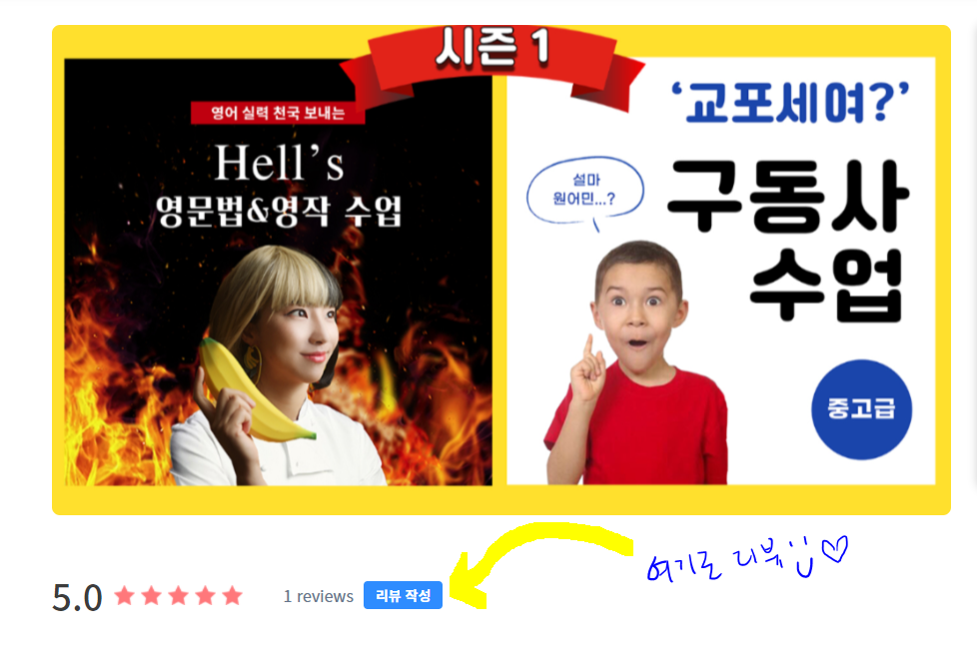
수업 완강을 축하드립니다
리뷰를 정성껏 남겨주시는 학생분에게 근사한 선물이 있어용!
https://liveklass.com/ch/bananaenglish
리뷰 남기러 가기

